**Market Trends and Consumer Preferences**

Murtuja Afshar

Debug-Tech Task 1

February 18, 2025

Exploring the current market trends and the consumer preferences has led to some insights that will be shared in the following report. A recent google trends search of the past 1 month shows that both men and women search regularly for apparels which ranges from clothes to skin care products. From the statistics of the men’s apparel search we can see that a majority of the search results constitute of Sport brands and sports apparels. A good example is brands like Nike and Adidas and when it comes to specific searches, men have been extensively been searching for Trainers, Trousers, Hoodies. There have also been searches for Clothing, Fashion, Boots, etc. Similarly, women’s Search trends have been quite similar when it comes to both popularity towards sports apparel and some other searches being towards fashion. The only particular search that was different in women’s apparel when compared to men’s was women also searched for leather products. 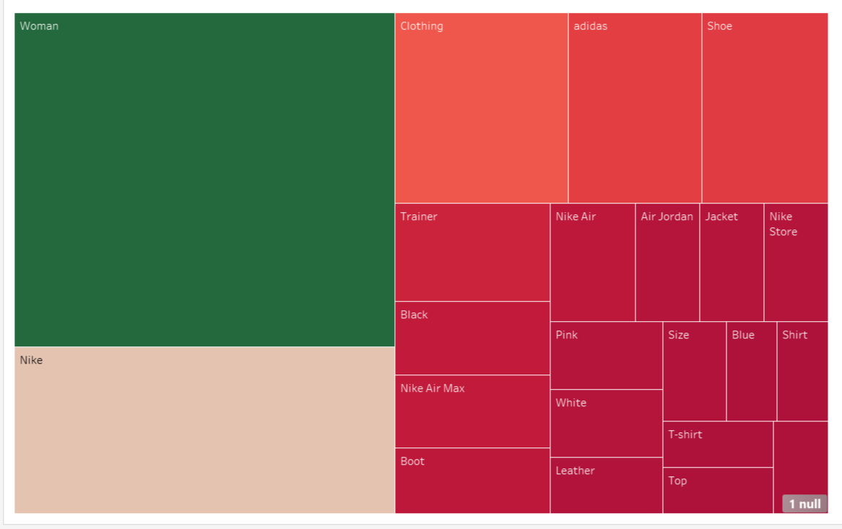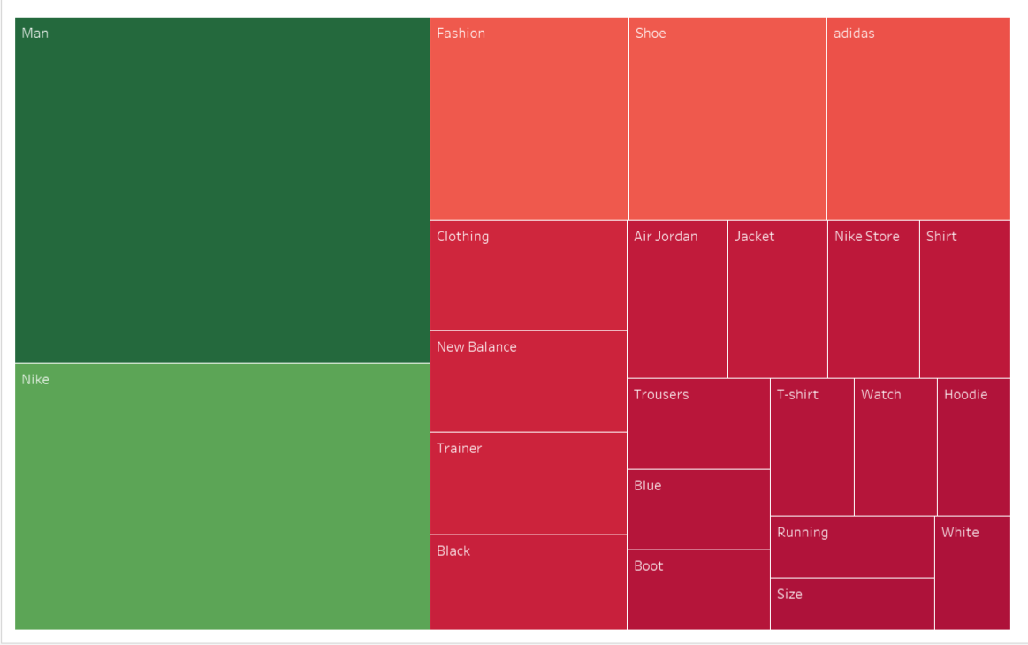

For further analysis I stuck to two sports brands Nike and Adidas and two fashion brands Zara and H&M. Nike and Adidas were obvious choice for the huge search portions that they occupied and Zara and H&M were chosen for their popularity and affordable luxury.

Peaks:  
Out of all the chosen brands as of 2024, Nike holds the highest brand value. According to Kantar's 2024 report, Nike's brand was valued at $71.6 billion, though this represented a 4.4% decrease from the previous year. In comparison, Zara's brand value stood at $27.1 billion (up 47.3%), Adidas at $16.1 billion (up 35.4%), and H&M at $5.96 billion (up 35.2%) ([EXEC: Nike’s Valuation Dips Again in Kantar’s 2024 Most Valuable Brands Study | SGB Media Online](https://sgbonline.com/exec-nikes-valuation-dips-again-in-kantars-2023-most-valuable-brands-study/?utm_source=chatgpt.com))s.

From the google trends statistics we can see that all the brands have a similar peak during 18th, 25th  of January and 2nd, 8th and 15th of February. These peaks are indicators of what leads people to search for fashion apparels during period of a month.

Reasons:

* Valentine’s day:

1. The search peaks on February 2nd, 8th, and 15th align well with the lead-up to and immediate aftermath of Valentine’s Day.
2. People often search for gifts, including fashion and apparel, to buy for their partners, which could explain the increased searches for brands like Nike, Adidas, Zara, and H&M.
3. Many retailers also run Valentine’s Day promotions, leading to increased searches for deals on clothing and accessories.

* Bi weekly payouts:

1. Many employees receive their salaries on a bi-weekly basis, often on Fridays (which aligns with peaks seen on January 18th, 25th, and February 2nd, 8th, and 15th).
2. Once people receive their paychecks, they are more likely to search for and purchase apparel, leading to increased Google search activity for these brands.
3. Budget-conscious shoppers might be waiting for their paychecks to make discretionary purchases like sportswear or fashion items.

* Increasing interest in physical health:

1. The beginning of the year is typically associated with New Year's resolutions, many of which are fitness-related.
2. The high search volumes for Nike and Adidas (sports brands) suggest that people are looking for workout gear, trainers, and sports apparel to support their fitness goals.
3. This aligns with the broader trend of increased gym memberships and home workout purchases in the first quarter of the year.

Specific brands:

1. Adidas:  
   From the data collected we can see that there are specific trends that highlighted the sale and some sub categories involve cleats. Adidas football and baseball cleats have been quite searched for.   
   Also there were searches related to Chinese new year adidas trends. Adidas had dropped some Chinese new year jackets, trousers and sneakers that became very popular. A insta post by “yung.denim” on 9th feb stating “Adidas has been cooking lately” received 48.1k likes.

Adidas’s Samba collection also garnered huge attention and this could be seen by a post made on 10th January by “[**sneakernews**](https://www.instagram.com/sneakernews/)” which has 10 million followers about Adidas Samba Cheetah print saying “Big cat themes are dominating sneakers right now. Later this January, adidas will drop a set of Sambas covered in hairy cheetah prints!⁠” which harboured 32.4k likes. From the search results it’s quite apparent that the new cheetah and leopard prints are excessively popular in the market.

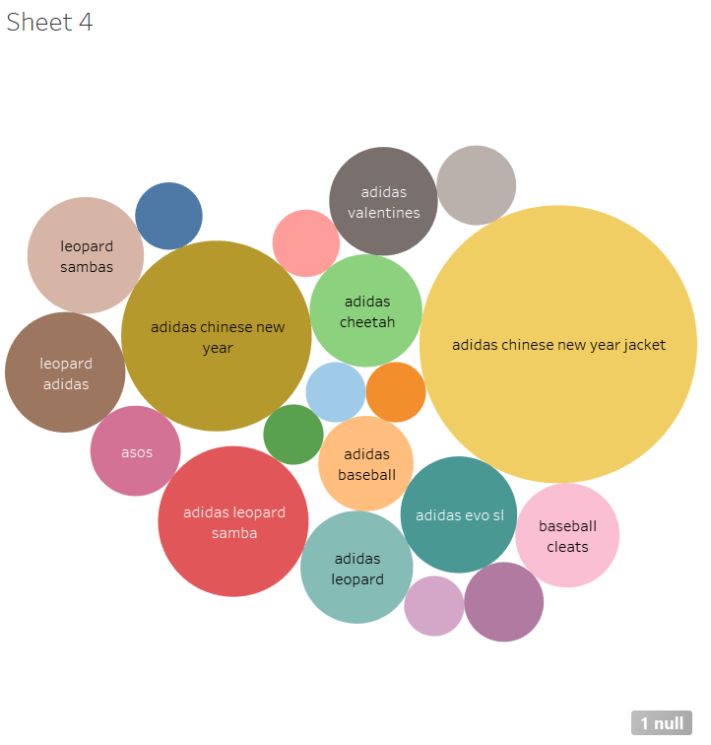

1. Nike:  
   Nike has been all the buzz with its brand new Jordans and Air max collections. Specifically its Air max collection has been collecting new admirers every passing moment. An insta post by “boostsfeed” on 23rd Jan about the “Nike Air Max 90 "Volcano"” gained 86.3K likes.  
   Similarly the Nike Air Max Plus TN, often called "TNs", features a unique gradient design, wavy overlays, and Air units for extra comfort ([Nike Air Max Plus – 2025 Official Release Dates | SneakerNews.com](https://sneakernews.com/tag/nike-air-max-plus/?utm_source=chatgpt.com)). An insta post by “sanjii_boyy” about the pink TN’s has 57K likes.  
   Nike Jordans were a fashion icon and still hold great control over the market this can be seen by the insta post by “[**insanesneaker**](https://www.instagram.com/insanesneaker/)”⁠ on 31st Jan about Jordan 11 stating “The Air Jordan 11 “Coldest in the Game” is expected to Release in Holiday 2025 ❄️ Y’all rockin’ with these?” which has 100.6K likes.  
   The brands reliability can be seen through its constant 4.8 average ratings by its customers on the Nike and other shopping apps.

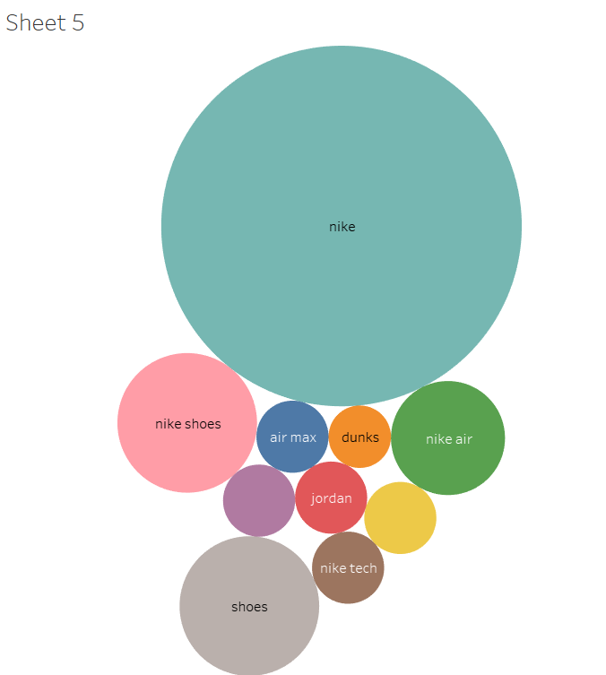

1. **Zara:**

Zara being a multisex brand has huge popularity among men and women. But Its popularity is a bit tilted towards the feminine part of the population and its value has been on constant rise as an affordable luxury. Its search is greatly dominated by dresses, jeans, jacket, coats etc. A quick scan through insta posts such as “style.beyondborders” weekly outfit zara clothing post which gained 30.1K likes, “[**edoschxx**](https://www.instagram.com/edoschxx/)” zara outfit which garnered 20.9K likes and “[**egipatskimauu**](https://www.instagram.com/egipatskimauu/)” zara outfit which had 47.4K likes shows the current frenzy about its popularity in the fashion world.

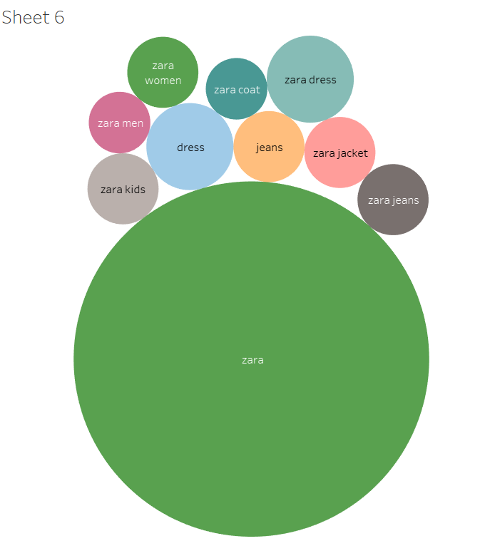

1. **H&M:**

H&M holds a similar kind of audience to Zara when it comes to demographics but its image is not that of a luxury brand but rather a mid-level (fast fashion) brand. Its search statistics revolved around dresses for men, women and kids. People also searched for stores of H&M near them which shows their interest in buying clothes directly from the store. Even though its popularity is lowest out of the chosen brands but it still holds huge significance with an estimated market value of 21.43 billion dollars as of february 2025 ([H&M (HM-B.ST) - Market capitalization](https://companiesmarketcap.com/h-m/marketcap/?utm_source=chatgpt.com)). Trending hashtags related to H&M are “#hm” and “#hmhaul”.

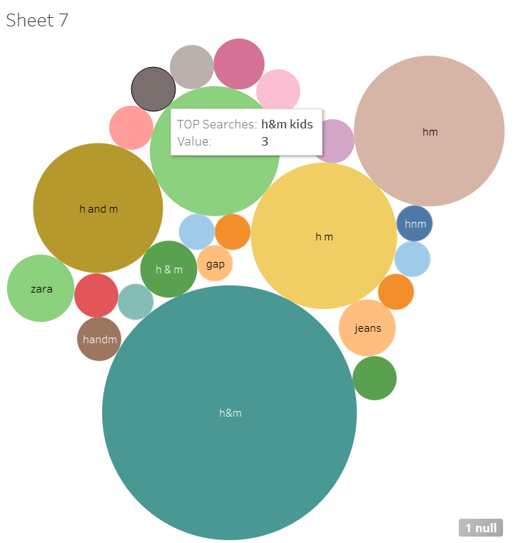

Conclusion:

Present market trends indicate that consumers are very interested in sportswear and fast fashion, with Nike and Adidas leading the way in searches for athletic wear and fashion as well and Zara and H&M being a significant part of the fashion market. Nike has asserted its dominance in the market by being almost 3 to 4 times more popular than the other 3 brands. Biweekly pay cycles, seasonal events (like Valentine's Day, Chinese New Year, etc.), and a growing emphasis on health are all having an increasing impact on consumers. Customers place a high value on brand recognition, affordability, and trend-driven purchases, according to digital platforms like Google Trends and Instagram. Fast fashion is still popular, but the growing interest in health and athleisure wear is driving growth for sportswear brands.

References:

[H&M (HM-B.ST) - Market capitalization](https://companiesmarketcap.com/h-m/marketcap/?utm_source=chatgpt.com)

[Nike Air Max Plus – 2025 Official Release Dates | SneakerNews.com](https://sneakernews.com/tag/nike-air-max-plus/?utm_source=chatgpt.com)

[EXEC: Nike’s Valuation Dips Again in Kantar’s 2024 Most Valuable Brands Study | SGB Media Online](https://sgbonline.com/exec-nikes-valuation-dips-again-in-kantars-2023-most-valuable-brands-study/?utm_source=chatgpt.com)